Meet The Teacher

Mrs. Camp

My name is Mary Camp. I am excited to be your second grade teacher for the 2019-2020 school year. I previous taught kindergarten for the past 15 years. This will be my 16th year at Freedom Park School. My husband retired from the Air Force. We have three children and two grandchildren. We live in Harlem and enjoy the quiet country life. I am excited to make this the best school year yet!

About Me:

Contact Me: Education:

My education includes a Bachelor’s Degree in Elementary Education, a Master’s in Counseling, and a Specialist in Curriculum and Instruction. I am also certified to teach Gifted students.

I love to hear from parents throughout the year. Please always contact me with questions or concern. 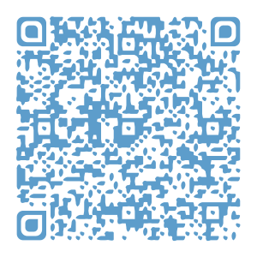Please scan the QR code to download my contact information into your cell phone.

My Favorites:

## Store: Walmart

## Food: Any Fruit

## Hobby: Reading

## Candy: Chocolate with nuts

## Fast Food: Chick Fil A

## Flower: Peonies or Tulips

## Drink: Water Fuji

Scent: Aromatherapy Stress Relief

Season: Spring

IIlo